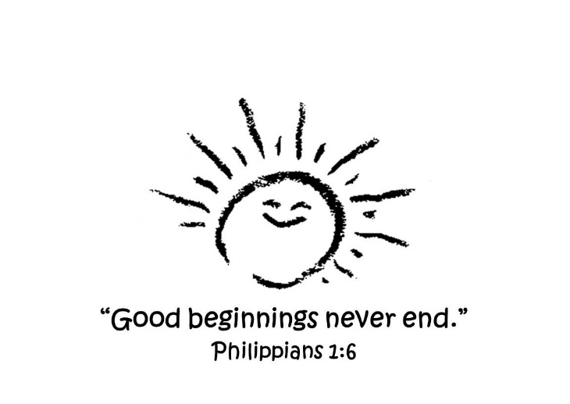**Yearly Calendar**

***2025-2026***

**August**

Thursday, 14th Parent & Child Orientation 9:00-12:00

Monday, 18th First Day of School for Preschool & Primary

Monday, 18th Mini Munchers begins with form

**September**

Monday, 1st Labor Day Holiday (No School)

**October**

TBD Fall Fundraiser

TBD Preschool & Primary Fall Picture Day

Friday, 10th District 5 Fall Break (No School)

Monday, 13th District 5 Fall Break (No School)

**November**

Sunday, 2nd Daylight Savings Time Ends (Fall back 1 Hour)

Tuesday, 25th Preschool & Primary Family Feast @ 11:30 in the gym (No Mini Munchers)

26th - 28th Thanksgiving Holiday (No School)

**December**

Thursday, 18th Happy Birthday Jesus Party at 11:30 in the sanctuary (No Mini Munchers)

Friday, 19th Teacher/Student Holiday (No School)

22nd – Jan. 2nd Christmas Holiday (No School)

***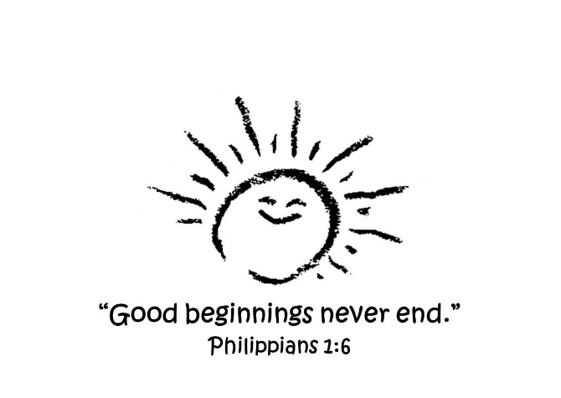*Yearly Calendar**

***2025-2026***

**January**

1st – 2nd District 5 Holiday (No School)

Monday, 5th Preschool & Primary Classes Start Back

Monday, 19th District 5 Holiday (No School)

**February**

Friday, 13th District 5 Holiday (No School)

Monday, 16th District 5 Holiday (No School)

**March**

TBD Spring Fundraiser

TBD Preschool & Primary Spring Picture Day

Sunday, 8th Daylight Savings Time (Spring Forward 1 Hour)

Friday, 13th District 5 Holiday (No School)

Monday, 16th District 5 Holiday (No School)

TBD Dutch Fork Church FAMILY EASTER CELEBRATION

**April**

Thursday, 2nd Preschool & Primary Easter Celebration Luncheon @ 11:30 (No MM)

6th – 10th Easter/Spring Break (No School)

**May**

Wednesday, 6th K5 Graduation Ceremony

Wednesday, 13th 4K Graduation Ceremony

Thursday, 21st Preschool & Primary Last Day & Luau Party Luncheon @ 11:30 (No MM)