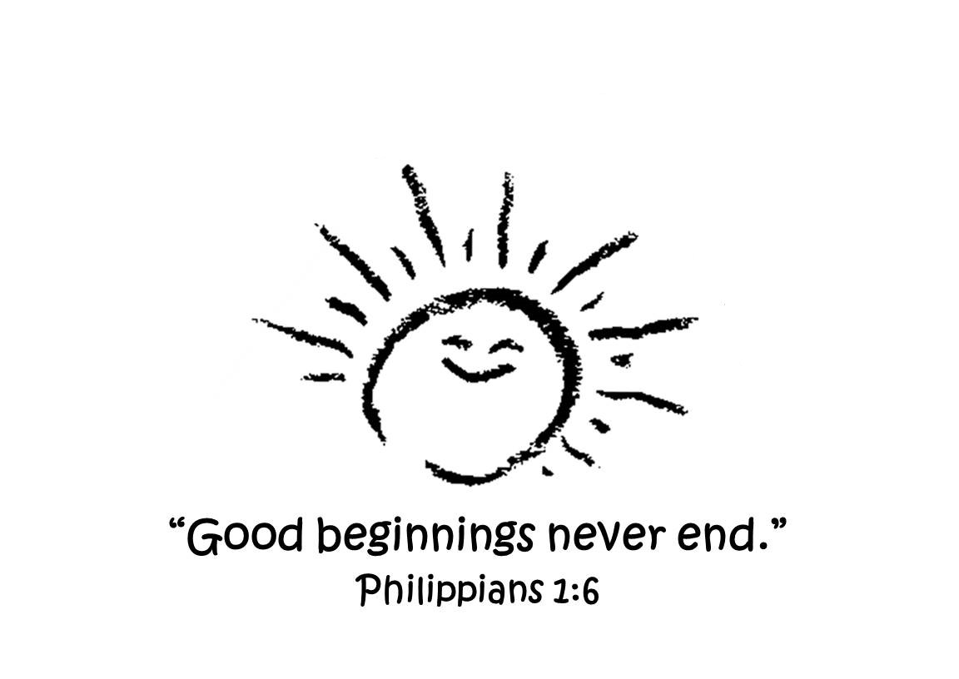
Dutch Fork Church K5
HOMESCHOOLING Partnership

Dutch Fork Church will facilitate a K5 program in partnership with a Homeschooling Association for the school year 2025-2026.

Important Information:
- Parents are responsible for registering with a Homeschool Association. The Homeschool Associations we are familiar with are:
SCAIHS (South Carolina Association of Independent Home Schools) @ http://schomeschooling.com
Palmetto Home School Association @ http://palmettohomeschool.org.
- Each Homeschooling Association will have a fee to join their program as well as require documentation through-out the year
- Provide a copy of your Association acceptance letter that confirms you are legally homeschooling your child
- DFC K5 will be 5 days (Monday-Friday), 9:00-1:00 or 9:00-2:00
- DFC Yearly Registration fee is $150/$250 per family (due at registration)
- DFC Yearly Supply fee is $125 and due with first month tuition
- DFC Monthly tuition fee information can be found on the registration form
- Curriculum along with supplemental material:
  - “Teach Your Child to Read in 100 Easy Lessons”, Siegfried Engelmann
  - “All About Reading”, Marie Rippel, Yellow Level Pre-1 and Blue Level 1
  - “My Math”, McGraw-Hill, Volume 1
  - Science/Social Studies: “Five in a Row”, Jane Claire Lambert
  - “Jesus Loves Me Bible Storybook & Devotional”, Angela & Ken Abraham
  - “God’s Love for You Bible Storybook”, Richard & Renee Stearns
  - Teacher Pay Teacher resources and other teacher materials
- Mrs. Paige Shealy is our K5 teacher; Mrs. Paige has 26 years experience with teaching young children, paigeshealy@yahoo.com, (803) 931-2342
- Mid-term report cards will be issued in December, if needed, and in May for your records
- For questions concerning our DFC K5 program contact Robin Broad, robinbroad@gmail.com

P. O. Box 345 . Ballentine, SC 29002 . (803) 781-2532
dutchforkchurch.org

