DUTCH FORK CHURCH

Parent Handbook

Robin Broad, Director
(803) 463-3482

P.O. Box 345. Ballentine, SC 29002. (803) 781-2532
Tax ID: 57-1094175
dutchforkchurch.org

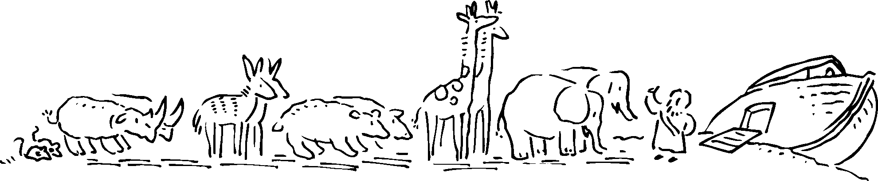
Rev. January 2025

An Outreach Ministry for the Family

Welcome

Dear Parents,
We are glad that you have decided to become a part of our Weekday Preschool & Primary Program here at Dutch Fork Church. We are looking forward to getting to know you and your child.
When your child attends our Weekday Program here, your child will build habits and attitudes that will help him/her learn and experience the environment around them. Our program offers children a place to learn and play with others; develop skills at their own rate; express ideas through group interaction; participate in creative activities, crafts, worship, science, and music; and grow in their knowledge of God.
Our goal is to provide quality-learning experiences in a Christian environment and to teach developmentally appropriate curriculum to our children that will promote high self-esteem and proper social development. The Preschool curriculum is a Bible based study from the “WEE LEARN” curriculum which is written and distributed by the Sunday School Board of the Southern Baptist Convention. Our Primary students meet state standards through partnership with homeschool co-ops such as SCAIHS (South Carolina Association of Independent Home Schools) and Palmetto Home School Association.
Our philosophy is that children's work is play and together we can give our children a wide variety of healthy experiences to learn from and promote a strong Christian foundation on which to build a future. We are thankful for the opportunity to extend our ministry to you and your family.

Our Mission Statement
Our Weekday Preschool & Primary Program mission is to provide a safe, caring, and nurturing Christian environment for children to learn and play. We minister to the spiritual, developmental, and social needs of children by providing a Bible-based curriculum that will teach them about God and His love for them and how they can experience God’s love through Jesus Christ. We do this through developmentally appropriate activities and instructional teaching that promotes an environment of creative and active learning.

A Teacher's Principal Function
An effective teacher must provide a caring and loving environment that adequately meets the intellectual, physical, emotional, social, and spiritual characteristics of the children in her classroom. Our teachers are trained in both Infant/Child CPR and First Aid.
A Message from Our Church

We take great pleasure in offering a Bible-based ministry that is designed to meet some specific needs of the children and parents of our community. Jesus, Himself, initiated this ministry when He took the children in His arms, put His hands on them and blessed them saying, "Let the little children come to me, and do not hinder them, for the kingdom of God belongs to such as these." (Luke 18:16)
Our Weekday Preschool & Primary staff is very much aware of the value and potential that is bundled up in the life of each child; and they take these words of Jesus to heart as they carry on a vital tradition of loving and caring for your children. We welcome the opportunity to minister to you and your family; and we count it a unique privilege to provide you with quality childcare.

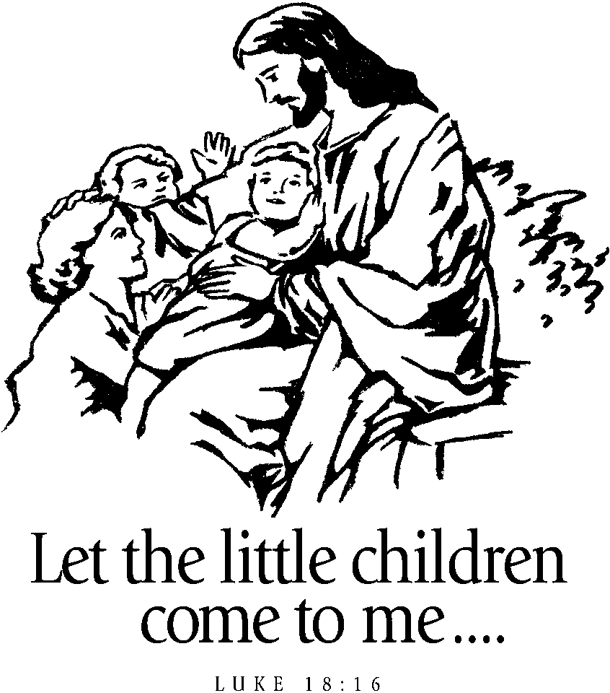

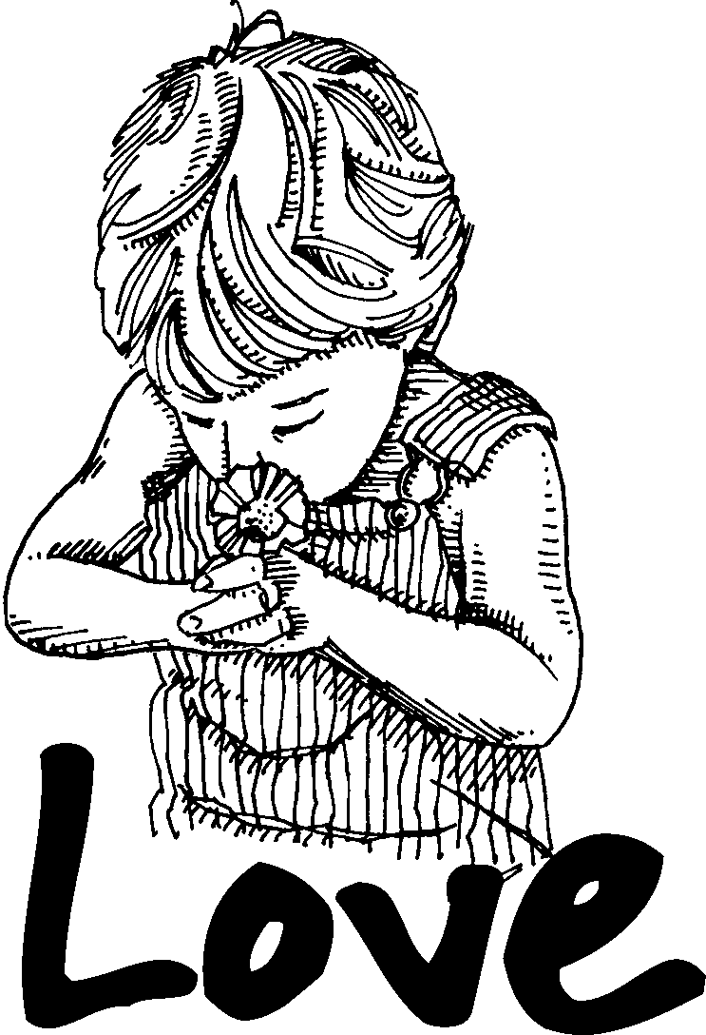

A Message for Parents

For Toddlers: Toddlers need to be steady walkers and out of their morning naptime. The age for our toddler class is around 16 months old up to those who turn 2 after September 1st. Your child will need a book bag (big enough to hold a standard folder) with extra diapers, extra weather appropriate clothes, and a labeled Sippy cup each day. Toddlers will listen to music, play with large manipulatives, look at books, listen to Bible stories, play in the gym, and have lots of fun activities. Toddlers DO NOT participate in preschool special events and need to be picked up from the classroom on event days.

For Preschool & Primary students (age 2 years and up): Your child will need a book bag (big enough to hold a standard folder) with diapers or VELCRO pullups and wipes (2-year-olds), and extra weather appropriate clothes. These students will do more structured activities including a Bible lesson, crafts, reading time, music, games, attend worship, and special events. Children must be fully potty trained to enter the 3-year-old classroom. Our program curriculum for 2 years – 4K is a Bible based study from the “WEE LEARN” curriculum and for our primary students we are in partnership with local/state home school co-ops to meet state standards.

Label all of your child’s belongings. This includes book bags, Sippy cups, jackets, lunch boxes, etc. We are not responsible for lost items.

Your Participation:
Parents are always welcomed to participate in any event at Dutch Fork Church. If you do not have a church home, you are welcome to visit us at Dutch Fork. Parents are always welcomed to participate in special events with regard to all health and safety procedures.

Communication:
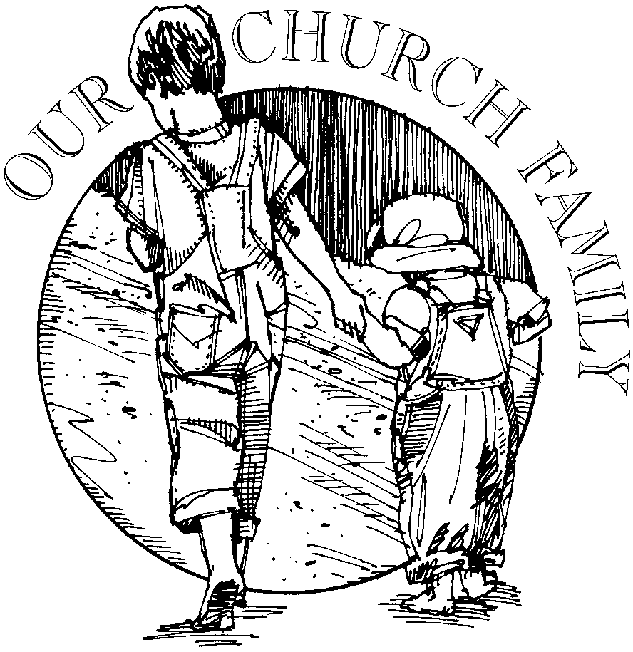
Parents are encouraged to talk to the teacher and/or director about their child's progress and well-being. Communication is extremely important to us. Call or talk with us concerning questions you may have. We also communicate through our folders. Place important notes to the teacher and tuition envelope in your child’s folder (placing notes or checks in your child’s book bag will be overlooked so please remember to place these items in your child’s folder). We try to check folders each day.

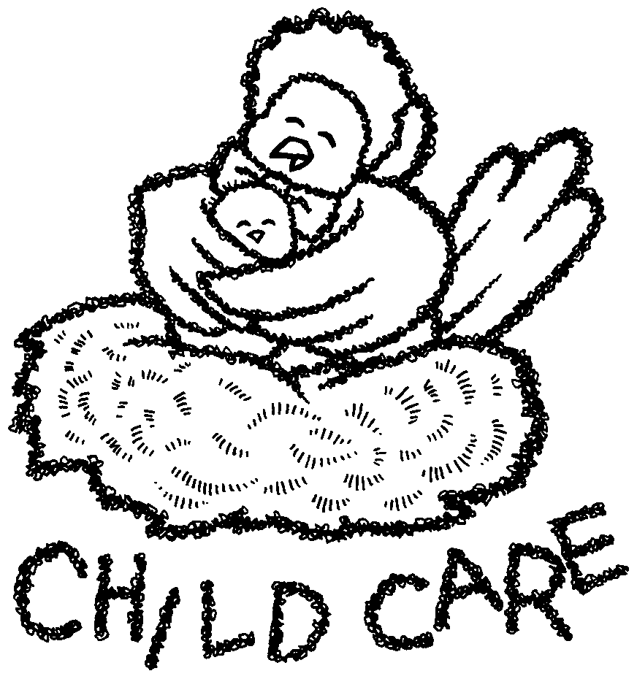
Weekday Preschool & Primary Policies

Classroom Birthdates
- Toddlers 16 months to 24 months
(Those around 16 months to those who turn 2 after Sep. 1st)
- 2 & 2 ½ year olds must be 2 by Sep. 1st
- 3 & 3 ½ year olds must be 3 by Sep. 1st
(Must be fully potty trained: must wear underwear, no pullups)
- 4 & 4 ½ year olds must be 4 by Sep. 1st
- 5 & 5 ½ year olds (K5) must be 5 by Sep 1st
- 6 & 6 ½ year olds (1st Grade) must be 6 by Sep 1st
Our goal is to place your child in a classroom with children of the same age and developmental maturity. In some instances, classrooms may be combined or another classroom established.

Class Times
Classes begin at 9:00 AM and end at 12:00 PM. Mini Munchers ends at 1:00 PM. Mini Munchers is for the 2-year-old classrooms and older. Be on time to pick up your child. Extended hours until 2:00 are also available for our K5 and 1st grade classes. Late pickup fees will be incurred for late pickups. See the Late Pickup Fee Policy in this handbook.

Fees and Tuition
Non-refundable Registration Fees are due at time of registration. Supply fees are due with the first month’s tuition payment. Tuition is due by the 15th of each month payable to Dutch Fork Church (DFC). A $20 charge will be incurred for tuition received after the 15th.

*Yearly Registration Fee is $150 per child or $250 per family and is due at time of registration.
*Yearly Supply Fee is $125 per child due with tuition when school begins
*Tuition Options: See the Registration Form

A $20 monthly discount is offered for families with more than one child enrolled.
Tuition is averaged for the year and due no matter how many days your child attends.

Payment Plans and Scholarships
Payment plans and limited scholarships are to assist families who meet certain requirements and can be addressed with the director. Regrettably, if fees are not paid, your child will not be allowed to attend school until payments are made. We strive to provide a ministry program that works with families and their needs by also providing fairness to all who are involved in our program.

School Schedules, Holidays, and Inclement Weather
Our school schedule is based on the Richland/Lexington District 5 schedule. Fall registration begins in February each year. Our Summer Term will be determined in the spring of each year. When District 5 has a holiday, closing due to inclement weather, or an E-learning/Virtual day we will also be closed. Watch your local news stations for District 5 schedule changes and closings. You will receive an email and/or a text from your child’s teacher with information about our school’s plans.

Special Events and Celebrations
Typically, throughout the year we celebrate special holidays (Thanksgiving, Christmas, Easter, and end of the year Luau) with family fellowship times where our children perform songs and simple skits for our families (2-year-old classes and older). Information about upcoming holiday celebrations will be posted in your child’s classroom newsletters and in our monthly memos.
Personal Belongings
Label your child’s belongings. This includes clothing, coats, hats, cups, book bags, etc. Do not send toys with your child to school. These items are disruptive and we cannot be responsible for these items if broken or lost.

School Attire
We encourage the children to participate in fun and active learning while at school. Dress your child in clothes that are suitable for play and can get dirty or stained. Dress your child in clothes so he/she is self-sufficient (2-year-old classes and older). Overalls, jumpers, long dresses, onesies, laces, buttons, and belts are frustrating for your child and can hinder them from being independent during potty breaks. Closed toe shoes are the best shoes for your child to wear as we have mulch chips for our playground covering.

Change in Transportation
Parents must provide a written note when there is a change in transportation. This is for your child's safety. Notes should be placed in your child’s folder. In an emergency, call the church office or text/call your child’s teacher or the director to notify the staff of a change in your child’s transportation. Your child will not be allowed to leave with anyone other than those specified in the parents’ written note or those listed on the child’s registration form. Identification will be checked before your child is permitted to leave.

Snack Time
Water and a snack will be provided for all children. However, we do encourage healthy snack donations (no peanut butter products or items loaded with sugar). Store bought mini cupcakes or cookies are fine to bring for your child’s birthday party. Please notify your child’s teacher if your child is allergic or sensitive to any foods.
Classroom Activities
We have many fun activities planned each day of school. Read the classroom newsletters and monthly calendars provided by your child’s teacher for information about current and upcoming events, classroom activities, and more. Look through your child’s folder each day for activity sheets and notes from the teacher.

Mini Munchers
Mini Munchers is an optional program that extends the day until 1:00. No peanuts or peanut butter is allowed at Mini Munchers. Provide your child with a healthy child friendly lunch that includes a drink such as a water bottle or juice pouch and plastic utensils if needed. Mini Munchers is for children in the 2-year-old classrooms and above. Pick up is by 1:00. Fees will be incurred for late pickups. Foods such as hotdogs, grapes, cherry tomatoes, and nuts must be pre-sliced due to the potential for choking. We do not heat food up. Provide a thermos for foods that need to stay warm. Make sure to label your child’s lunch bag, drink cups, and containers.

The cost is $15 per month for each day enrolled and payment should be included with tuition. No refunds or makeup days for holidays or absences. A Mini Muncher form is included in your child’s information folder. Drop-ins are welcome but limited at $5 per day.

K5 & 1st Grade Homeschool Partnership
Our K5 & 1st Grade five day program at DFC is a partnership with a local/state Homeschooling Association for the school year. Parents are responsible for registering their child with a homeschool association and will be provided an acceptance letter to confirm that they are legally homeschooling. Associations we are familiar with are: South Carolina Association of Independent Home Schools (SCAIHS), schomeschooling.com, and Palmetto Home School Association, palmettohomeschool.org. All school fees noted in this handbook will be applied to our K5 & 1st Grade program. We require a copy of each family’s homeschool association acceptance letter. Our Primary homeschool association program will facilitate meeting the state requirements and standards in reading, writing, math, science, and social studies. Curriculum along with supplemental materials are as follows:
K5:
  - “Teach Your Child to Read in 100 Easy Lessons”, Siegfried Engelmann
  - “All About Reading”, Marie Rippel, Yellow Level Pre-1 and Blue Level 1
  - “My Math”, McGraw-Hill, Volume 1
  - Science/Social Studies: “Five in a Row”, Jane Claire Lambert
  - “Jesus Loves Me Bible Storybook & Devotional”, Angela & Ken Abraham
1st Grade:
- “Project Read: First Grade Phonics”, V. Greene and M. Enfield Ph.D.
- “Empowering Writers”, Barbara Mariconda
- “Math Expressions”, Dr. Karen C. Fuson
- “God’s Love for You Bible Storybook”, Rich & Renee Stearns
- “Your Every Day Read and Pray Bible for Kids”, Janice Emmerson


Drop-off and Pickup Guidelines
Due to our Health and Safety procedures, no non-essential visitors are allowed into the building.

Morning drop-off: Car line drop-off is 8:45 - 9:05am. Late drop-offs, ring the preschool doorbell and a staff member will receive your child at the door.
Toddler Drop-off: Pull forward through carline to the preschool door for a staff member to receive your child.
Afternoon pickup at 12:00: Car line is 11:55 – 12:05.
Toddler Pickup: Pull forward through carline to the preschool door for a staff member to put your child in the car.

Car Line Guidelines:
- Entrance and Exit signs are posted.
- DO NOT walk up to the gym door during car line pickup time.
- Each family will receive a car line tag. Each additional tag is $1.
- Place your car line tag around rearview mirror.
- Have your child’s car seat on the driver’s side, if possible.
- In the morning unbuckle your child while waiting in car line.
- In the morning and afternoon, pull forward to the yellow line so that we can service three cars at a time.
- In the afternoon, we will put your child in their car seat. We have a “No Buckle” policy. Pull forward into a parking space and buckle your child into their car seats.
- Make sure your car is in PARK to receive your child and wait until the teacher has cleared the car before driving forward.
- During car line we do not have time to talk about your child’s day. Please check your child’s folder each day for notes or call if you have questions or concerns.
- In the winter we do keep the doors closed to conserve heat.
- Late fees will be incurred for late pickups.

Afternoon pickup at 1:00 and 2:00 (K5 & 1st Grade only can be enrolled in 2:00 pickup): If children are on the playground, you must park your car in a parking space and walk to the playground to pickup your child. During inclement weather, the children will be in the gym and drive around pickup will be in effect.

Reasons may arise to cause late pickups. However, our late pickup policy is very strict and fees will be incurred for late pickups. Please see the Late Pickup Fees Policy in this handbook. A curtesy warning will be given for a first time late pickup. Thank you for your cooperation in helping the car line run safely and smoothly!
Late Pickup Fees Policy
Our policy is that children must be picked up on time, starting at 12:05/1:00/2:00 depending on enrollment. Late fees are $1 per minute starting at 12:05/1:00/2:00 and $2 per minute after 10 minutes late. A warning will be given for a first-time late pickup.

Unfortunately, late fee policies have to be established due to families who are consistently late picking up their children from school. We understand that emergencies arise and that traffic can be an issue, however, we expect all children to be picked up on time. Traffic issues do not excuse the late fee that will be charged. Remember that banks, the post office, and doctor’s offices do not stay open late for your convenience. When children are picked up late, teachers are required to remain working and therefore unable to keep their commitments. Again, families will receive a warning for a first-time late pickup.

We love all of our children enrolled in our program and we do our very best each and every day to care for them. However, this policy must be honored for your child to continue to be enrolled with our program. Excessive late pickups will result in the cancelation of your child’s enrollment.

Potty Training
Potty training is a developmental milestone for our children. Potty training begins at home but our goal is to assist families in this important area of a child’s development. Let your child’s teacher know when you begin this important process with your child and any special instructions that you use at home that may be helpful to the teacher while your child is at school. Remember that overalls, jumpers, long dresses, onesies, laces, belts, and buttons are frustrating for your child, therefore, dress your child in clothing that is easy for your child to pull up and down. Provide VELCRO SIDED pull-ups while your child is at school. These make “potty tries” easier for both child and teacher.

In the 2-year-old classroom we go to the potty as a classroom. Your child will be taken for a “potty try” at frequent intervals. Make sure your child has plenty of clothes and extra VELCRO pull-ups. Special treats will be given for successful potty tries.

Children must be fully potty trained to wear underwear/panties to school.

Children must be fully potty trained before entering the 3-year-old classroom and must enter the 3-year-old classroom wearing underwear/panties, NOT pull-ups.

These policies are in place to ensure a quality teaching and learning environment. Our goal is to have classrooms where children are learning and growing together and where children are expected to meet developmental milestones that encourage confidence and well-being. If you have any questions concerning this topic, see the director or teacher for helpful techniques. Remember, consistency is the key!
Recycling Aluminum Cans
We recycle aluminum cans as a great way to keep God’s world clean and to teach children the importance of reusing our resources wisely. The collection bin is located on the opposite side of the church from the playground.

Graduation
A graduation ceremony will be held each year for our 4K and our K5 students with full cap and gown attire. The ceremony consists of scripture reciting, songs, personal letters to parents, favorite activities during school, future plans and careers, presentation of diplomas, and much more. Everyone is invited to attend.

1st Grade End-of-the-Year Celebration
At the end of the year, we have a family celebration to honor our 1st grade graduates. This is a time to celebrate our children with special presentations, good food, and lots of fun activities for the graduates and their families.
End of the School Year LUAU
At the end of each year, we have a Luau celebration for the children in our school (2-year-old classes and above). We have a variety of stations where the children can make crafts, play games, and lots more. The festivities are followed by a luncheon at noon. This is a time to celebrate a year of fun and learning with our children and their families. All celebrations and special events will be updated as the year progresses.

Child Discipline
Our school is committed to providing children an opportunity for quality learning in a safe and loving environment. A major part of this obligation is to use a system of discipline that will provide a positive learning experience leading each child to develop a strong sense of individual worth and responsibility. We believe positive reinforcement encourages positive behavior. The following are guidelines for handling discipline:
- No corporal or physical punishment.
- All behavioral expectations are developmentally and age appropriate.
- Use of consistence, fairness, and patience.
- Use of encouragement for positive behavior.
- Use of logical consequences (Acceptable consequences are removing child from one play area to another, limiting play privileges, and using "time out").
- The director will involve a child's parents/guardian in the disciplinary process when uncontrollable behavior and/or behavior that is harmful to the child or others persist.
- The director and the teacher will work with the parent/guardian to guide the child to develop appropriate behaviors in the classroom and when relating to his/her peers.
- If disciplinary issues persist and do not improve, the child will be removed from the classroom and potentially from the school.
Children are supervised by sight as well as sound at all times.
Illness Policies and Procedures
Health and safety are of utmost importance at Dutch Fork Church. We are committed to do all that we can to carefully and intentionally provide a safe learning environment for all who participate in our ministry. These procedures may be changed at any time.

Monitoring and Preparing:
- Screen children daily upon arrival for visible illness symptoms. Children should not be brought to school if they are not feeling well or have illness symptoms that can be contagious to other children or staff.
- In the case of a sick child during school hours, parents will be notified and required to pick up their child within 30 minutes of being notified. Any child sent home with virus-like symptoms will not be allowed to return to school until they are symptom free for a minimum of 24 hours.
- Parents are required to keep children home if exhibiting symptoms of any illness. If your child requires fever medication they should not be brought to school.
Health and Safety Actions:
- Clean and disinfect frequently touched surfaces daily.
- Minimize toys and manipulatives that are not easily cleaned or disinfected regularly.
- Keep all cleaning materials in a safe place away from children.
- Reduce large group gatherings in the gym and on the playground in an attempt to minimize exposure throughout the school.
- Prohibit nonessential visitors into the building during school hours.
- Stagger the use of common areas such as the playground, bathrooms, and gym and disinfect these areas daily.
- Our lunch program does have combined ages however surfaces are cleaned daily.

Health Requirements
An up-to-date immunization record is required for each child when they begin school.

The health of our children is a combined responsibility of the parents and the school. Communicable childhood diseases are inevitable in early school environments but can be kept to a minimum if symptoms are noticed and parents are diligent to keep their child at home. Notify your child's teacher/director whenever your child is exhibiting symptoms of a communicable disease. A child showing illness (fever, vomiting, diarrhea, etc.) will be promptly isolated from the other children and expected to be picked up within 30 minutes of notification. Children should be free of symptoms for at least 24 hours before coming back to school. Children with the following illnesses are expected to remain at home:
- Communicable or contagious disease
- Sore throat or swollen glands accompanied by fever
- Blisters in mouth, on hands and/or feet
- Undiagnosed rash or skin eruptions
- Earache accompanied by fever
- Green, thick runny nose
- Undiagnosed red eye or drainage from eyes
- Fever of 100 degrees or above
- Vomiting or diarrhea within the past 24 hours
- Untreated head lice or scabies

All families are required to sign a waiver stating they have read and understand our policies and procedures within this handbook.

Dutch Fork Church
Weekday Preschool & Primary
Church office (803)781-2532

Staff Members
John Bremer Associate Pastor of Worship & Discipleship

Jeanne French Ministry Assistant

Robin Broad Preschool & Primary Director

Jamie Elkins Toddler Teacher

Amber Payne Toddler Assistant

Jessica Smith Teacher for 2-year-olds

Kinslee Filler Teacher for 2-years-olds

Harriet Barbee Assistant for 2-year-olds

Tina Martin Teacher for 3-year-olds

Diana Issa Teacher for 3-year-olds

Christi McManus Teacher for 4-year-olds

Christina Pazarena Teacher for 4-year-olds

Abbie Hill Assistant for 4-year-olds

Paige Shealy Teacher for Kindergarten

Amber Redmon Teacher for 1st Grade

KC Paulk Assistant for Kindergarten & 1st Grade,

