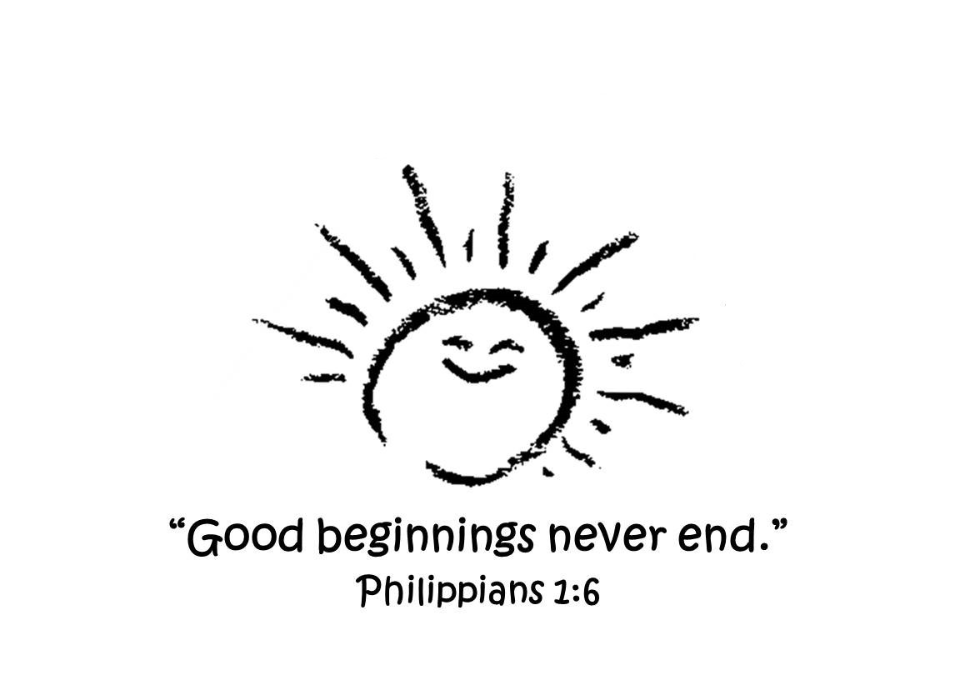
Dutch Fork Church 1st Grade
HOMESCHOOL Partnership

Dutch Fork Church will facilitate a 1st GRADE program in partnership with a Homeschooling Association for the school year 2025-2026.

Important Information:
- Parents are responsible for registering with a Homeschool Association. The Homeschool Associations we are familiar with are:
SCAIHS (South Carolina Association of Independent Home Schools) @ http://schomeschooling.com
Palmetto Home School Association @ http://palmettohomeschool.org.
- Each Homeschooling Association will have a fee to join their program as well as require documentation through-out the year
- Provide a copy of your Association acceptance letter that confirms you are legally homeschooling your child
- DFC 1st GRADE will be 5 days (Monday-Friday), 9:00-2:00
- DFC Yearly Registration fee is $150/$250 per family (due at registration)
- DFC Yearly Supply fee is $125 and due with the first month tuition
- DFC Monthly tuition fee information can be found on the registration form
- Curriculum along with supplemental material:
  - “Project Read: First Grade Phonics”, V. Greene and M. Enfield Ph.D.
  - “All About Reading”, Marie Rippel, Levels 1 & 2
  - “Math Expressions”, Dr. Karen C. Fuson
  - “God’s Love for You Bible Storybook”, Rich & Renee Stearns
  - “Your Every Day Read and Pray Bible for Kids”, Janice Emmerson
- Mrs. Amber Redmon is our 1st Grade teacher and has taught at DFC for 3 years. Mrs. Amber graduated from Winthrop University with a BS in Early Childhood Education. She has four years experience teaching first grade in Richland 1 and experience as a reading interventionist for K-5th grade; amber.redmon31@gmail.com, (803) 397-6859
- Report cards will be issued in December and in May for your records
- For questions concerning our DFC 1st GRADE program contact Robin Broad, robinbroad@gmail.com

P. O. Box 345 . Ballentine, SC 29002 . (803) 781-2532
dutchforkchurch.org

